**NATUROPATHY DIET SIDE EFFECTS AND TREATMENT**

A naturopathy diet is said to eliminate toxins from our body and initiates the flow of healthy cells in it. But is naturopathy diet unhealthy in any way? If it is, what are the drawbacks of naturopathy diet and what are the problems with naturopathy diet? What might be the naturopathy diet side effects?

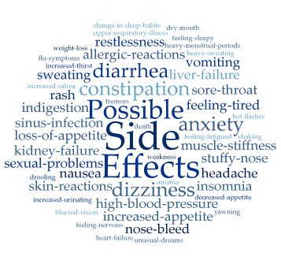

Naturopathy diet is said to cure various problematic issues like food sensitivities, immune disorders, high cholesterol, insomnia, stress, anxiety and many more. But there stand some negatives of naturopathy diet rigidly to neutralise the good effect, or maybe naturopathy diet side effects prove to be worse.

**Why naturopathy diet is bad?**

Naturopathy diet stands on a very shaky foundation which has no firm implications and is totally based upon experiments performed by a group upon themselves! That shows to an extent why naturopathy diet is bad and associated naturopathy diet side effects.

Blind faith in any condition doesn't always bears sweet fruit. Sometimes, expert advice (here, doctors or pharmacists) is good to make a sudden move beneficial. There are many associated problems with naturopathy diet too. Some are listed below:

• Naturopathy diet plan advices to take fruits and vegetables as they are- raw. The disadvantages of naturopathy diet here is that raw foods are hard to digest and problems like indigestion, constipation are likely to happen. Because there is a reason why Humans started cooking food instead of eating it raw! Why is Naturopathy diet unhealthy and causing you uneasiness with naturopathy diet side effects? A strong reason can be raw food.

• Naturopathy diet advices to go for fasting as long as possible (sometimes, a month long). Fasting surely lessens calorie intake and burns stored fat for energy but due to eating small quantities of food, the fuel which is constantly lit in our stomach reduces its strength. This causes our digestive system to work as a low power engine. This problem adds up to drawbacks of naturopathy diet.

• Naturopathy diet advices to take water in as large amounts as possible (preferably 7-8 glasses full in a day). If too much water remains in stomach for long time (if your digestive tract is not already healthy), you will feel tiresome all time! Why? Because full stomach becomes heavy and looks for resting whenever possible. Gas problems may follow.

• Naturopathy diet suggests to shift on a pure whole fruits and vegetables diet. Fruits and vegetables must be termed as 'super healthy' but excess to anything leads to ruptured paths. Similarly, diet containing only fruits and vegetables are not proven beneficial without a balanced and planned diet. Another feature that shows why naturopathy diet is bad.

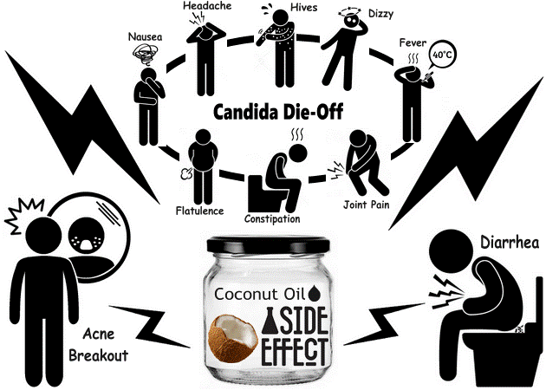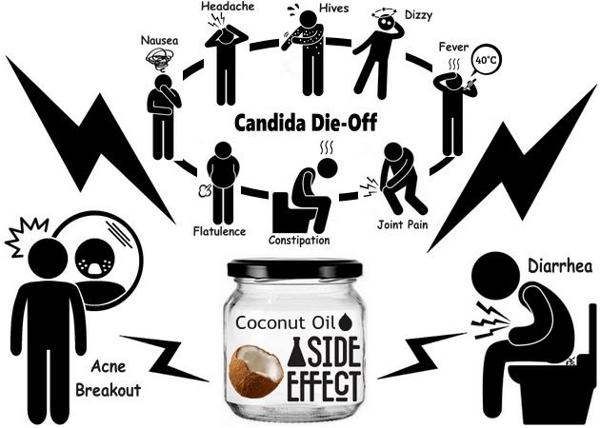

These are some disadvantages of naturopathy diet. But the question arises, why is naturopathy diet unhealthy if it ensures to provide a healthy lifestyle with early-mentioned advantages?

People tend to follow trends and adapt them quickly in their lives which is not a right move. A better way to get rid of a problem is to measure the extent of cause. Many health problems with naturopathy diet occurs to those who in spite of checking their body capacities and capability limits reach to try experimental data facts. In this situation, disadvantages of naturopathy diet are must to read.

For example, some people are prone to allergies caused by herbal products! But herbal products are suited to all? That's what a major myth believed by millions today and adds to negatives of naturopathy diet! Herbal and natural supplements too can diminish your body's ability to work more efficiently or may even affect your immune system (if not taken properly). What if you already going through the Naturopathy diet side effects? Worry not! Naturopathy diet side effects treatment is a road to step on!

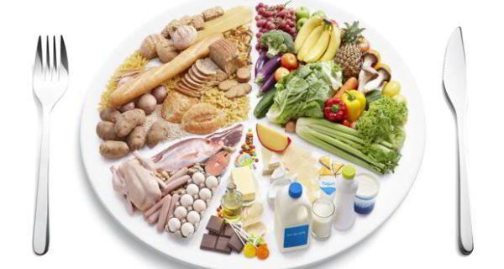

**Naturopathy diet side effects treatment**

The drawbacks of naturopathy diet can be treated well and reciprocated to provide beneficiary results! Naturopathy diet side effects treatment includes a proper diet plan consulted by a recognised authority. A mixture of all essential greens and nutrients is strongly recommended. Wait no more and try out a variety of foods keeping in mind their positives and negatives.